Week 1:

Discussion 1: Relation of research to child’s development

In your first chapter you read a little about research techniques. For this discussion board relate research to child development. Some suggestions would be how you feel about correlation, or prediction. You can also look at these websites to learn more about the normal curve and central tendency:

http://webspace.ship.edu/cgboer/descstats.html

Research in order to learn the health of the child development, it is better to research and understand conditions that affect children. When research is conducted, information gathered can be useful in the development of the child. Information can be used to create prevention, intervention programs and help communities to plan health services for children and impact their development. Researching on the health of the child is investing in our future. On the other hand, information gathered on child development reduces health cost to the society as well as tangible cost such as medical care, foster care, and social services (Schopler, Et. al., 2016).
Research is important for the better understanding of the childhood mental disorders and to better understand the child’s behavioral, emotional, and mental health. When research on child’s development is conducted, it is easier for the society to understand different health conditions that affect the child such as mental disorder and other public health issues affecting the child in the society. The information can be used in preventing developmental delays for children, for example children living in poverty. On the other hand, this information is important in enhancing parent-child interactions and have the child grow emotionally and healthy (Bukatko & Daehler, 2012).
Correlations are patterns in data. For example, mothers who synchronized their movement with that of their babies had a good rapport with them. Correlation means that things occur together. For example, mothers who fail to do mother baby dance are most likely to have babies who cry more than any other baby does. Correlation in research about the child development is important as it determines how the child grows and most likely, how they will be in the future in relation to their current development. Correlation therefore helps parents to predict how their children will grow and the right development conditions that are needed for the right development of the child (Bukatko & Daehler, 2012).
References
Bukatko, D., & Daehler, M. W. (2012). Child development: A thematic approach. Belmont, CA: Wadsworth.
McDevitt, T., Ormrod, J., Cupit, G., Chandler, M., & Aloa, V. (2012). Child Development & Education eBook. Melbourne: P.Ed Australia.
Schopler, E., & Reichler, R. J. (2016). Psychopathology and Child Development: Research and Treatment. Boston, MA: Springer US.

Week 2:

Discussion 2: For this discussion please read Chapter Two and write about which of the theories mentioned seems to make the most sense to you.
You should have already seen Piaget’s and Erickson’s Theories in the Chapter Notes. There are others in the book as well. Many psychologists today are eclectic or at least are willing to use different parts from different theories to help clients in the way that best suits them individually.
So, which one makes the most sense to you?
Discussion 3: This module explores some reasons why we develop into the people we become based on heredity. So, let’s look at the opposite side and consider how the environment (or “nurture”) influences our development. Some of this is based on the culture in which we grow-up. Can you think of things in our environment (remember – anything that is not genetic) that influences or affects child development?

Discussion 4:
This chapter is about prenatal development so I thought it would a good time to talk about stress-relief for parents. It’s important for parents to decrease stress levels during pregnancy as it can adversely affect the developing fetus and also the mother’s health. In addition, you want to decrease stress or your reaction to it whether your children are infants, toddlers, school-age, or teenagers. Infants and children pick up on parents’ emotional states and will react in kind. Also, you can’t take care of others unless you take care of yourself. So, what are some things you do to de-stress that you could recommend to parents? If you are already a parent and have some good strategies please share them here. I hope someone will talk about giving yourself a “time-out” if you need it. Time-out is not a punishment for parents; it’s giving yourself a moment to catch your breath and gather your thoughts.

Assignment 1. M4

Prenatal Assessment
Answer the following questions in 3 to 5 comprehensive paragraphs.
- “What risks are associated with various prenatal assessment measures?
- How are decisions made regarding which measures to use?
- What are some ethical considerations in the use of prenatal monitoring procedures?”
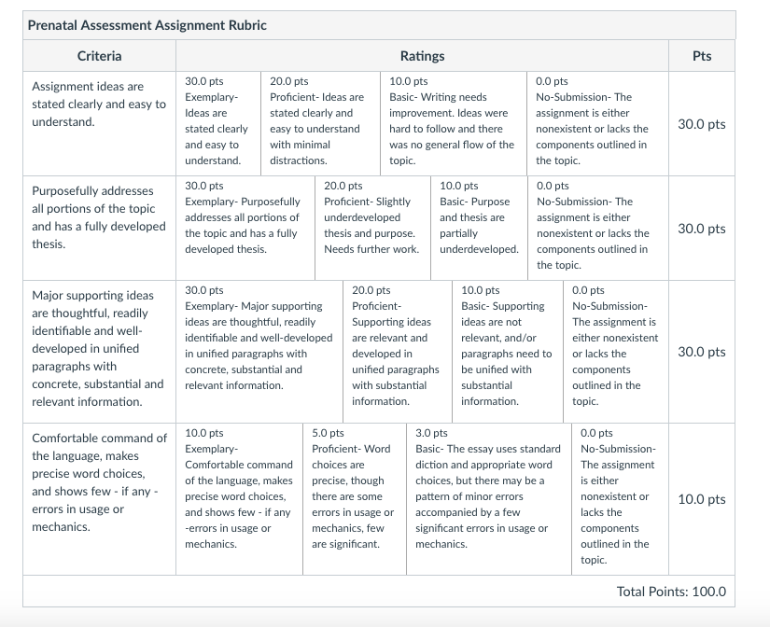

Week 3:

Discussion 5: Empathy
When I first started to work in a parenting program I was taught that there was a relationship between empathy for children and abuse. Specifically, those who have a lot of empathy for children are not as likely to resort to abusive behavior. Empathy is simply drawing on your own emotional experiences and relating them to others. We have all been children, so there shouldn’t be anyone who can say he or she doesn’t understand how it feels to be a child.
In my face-to-face classes, I bring in crayons, markers, and colored pencils and ask my students to draw with their non-dominant hand a picture of their family doing something. This picture is something we ask children do to draw all the time in counseling. Using your non-dominant hand gives you a little reminder of how hard it was to write neatly in first grade when your fine motor skills are still developing. You can try it yourself at home! Of course it isn’t the same because you have experience with your dominant hand, but I hope it helps to serve as a little reminder.
So, whether you’d like to try that exercise or you would like to share some ways you think that parents can remember what it’s like to be a child please share here. For instance, I’m sure you can remember feeling frustrated at some point in your life when you couldn’t communicate what you really wanted. Toddlers go through this all the time. Temper tantrums are actually from frustration. They tend to decrease as children improve their language skills.

Discussion 6:

Cultural Differences in Child Rearing
In this module you will read a little about cultural difference in language development. I thought I’d open this topic up to differences in child bearing and child rearing in general. You can share your own experiences or look up some information on the internet. Just be sure to cite your sources for this and the other discussion boards.

Discussion 7: Imitation
Children learn a great deal through modeling and imitation.You will read a little about the Bandura’s Bobo Doll experiment in the next chapter, but here is a preview: Let's discuss psychosocial development within the initial two years of life. Students are welcome to reflect on the Socio-Cognitive theory, as well as, content that may be relevant within the chapter.

Assignment 2. M5

Gross Motor Development
Answer the following question in 3 to 5 well structured paragraphs.
- “Describe differences in the gross motor development. How do these differences illustrate the cephalocaudal and proximodistal principles?”
Assignment 3. M6

Language Development
- Discuss the importance of environmental supports for language development. Provide examples that illustrate environmental supports, including child-directed speech, joint activities, expansion, and recasts.
Be sure to include at least 3 examples with explanation of each in this 3 to 5 paragraph assignment.

Week 4:

Discussion 8:

Eating Disorders
Please remember that this is a psychology class and in order to grow you will be asked to go outside of your comfort zone. I hope you can open yourself to information that can help you grow as a person and help others. In addition, you will encounter beliefs different from your own. These discussion boards are not be used as a platform to convert others to your way of thinking however. They are to introduce you to important concepts in psychology and human behavior.
Let’s discuss eating problems in childhood. You can write about three different choices.
1. What can be done to treat obesity in childhood? How can we teach children to eat healthy overall while still enjoying dessert and treats?
Let me give you some information that you can expand on:
- We have a preference from birth for sweet things
- Sometimes candy is used as a reward
- High fat foods are flavorful and come in different colors and shapes to appeal to children
- Commercials/Advertising
- Holidays/Birthdays – associated with sweets
- Nagging – is associated with eating good (who likes to be nagged?)
- Modeling – what do parents eat?
2. On the other hand what can be done to address the fact that children are actually worried about their weight to the point of going on diets when they are not obese?
For example, while there is more awareness of how the media contributes to having a negative body image, we still have a lot of teenagers developing eating disorders. There are even children (under 12 years) who are dieting so they can look like the stars in magazines.
While this was always predominately targeted at women, the same thing seems to be happening to men today. Look at some commercials or magazines. What do the men and women look like? Do you think this is realistic? Did you know how much airbrushing goes on to make models who are already too thin look even thinner? Did you know how many men feel pressure to take steroids today? You can discuss your thoughts here.
3. Solving eating problems in general. Preschoolers sometimes will naturally eat more of a low energy food and less of a high energy food they are getting the energy intake that they need. Many problems with children refusing to are caused by power struggles.
Some general tips:
- Model good behavior
- Introduce new foods/expose children to new foods
- Don’t force feed/don’t leave food out for hours waiting for your child to finish
- Make it fun (ex. broccoli trees)
- Make rules you can live with
- No emotions/be matter of fact
- Never make children clean their plate. This teaches them to ignore our bodies telling us we are full, which in the future can lead to obesity
- Make sure portions are small for children not just your perception of small
- Cut up the food into small pieces
- Don’t use food as a reward or punishment (exception if you eat most of your dinner you can have dessert)
I myself have a couple of stories I wanted to share here:
One time I had a woman tell me that her daughter only would eat fast food Kid’s Meals for lunch and dinner (this was before the more healthy Kid’s Meals). I was trying to get to the bottom of the problem as the mother was insistent that she was almost the “victim” in this situation and that her child made her go out for fast food every day. So, I just had to ask her if her six-year-old daughter actually got into the car and drove down to this restaurant every day and purchased her Kid’s Meal. She had to laugh at the thought, which was good. My point was actually that someone else besides the child was providing the fast food and someone besides the child would have to put it to an end.
Another time I worked with an amazing mother who was able to really take my advice and run with it. Her child would only eat (let’s say for the sake of confidentiality) peanut butter and jelly (PB&J) sandwiches for lunch and dinner. The mom admitted it was a power struggle and that meal time had become very stressful with her trying to get her daughter to eat something else and finally giving in to her demands. Since this was a power struggle, the child was nine-years-old, and the child was eating breakfast foods and whatever was offered at school for lunch, I knew the only way to get rid of it would be to get rid of the source. So, I told this mother to give her child the PB&J sandwiches without emotion. I told her to be matter of fact and just have it waiting for her for (weekend) lunches and dinners. I knew that this would end the power struggle and also that because of how or taste receptors work, she would lose interest. As predicted, the first night the child sat there in awe that her mother had just given her what she wanted and wasn’t engaging in a power struggle. This mother was just wonderful. She didn’t talk about it or acknowledge it. She acted like it was the most normal thing in the world. In the meantime, she made herself whatever she wanted to eat. Within about three weeks the child started to get bored with her favorite food. It was very important at this point that her mother did not comment on it or say something like, “See, I knew this would happen.” She just ignored her child obviously not enjoying her favorite food anymore. Then when her child asked to try what her mom was having she was again matter of fact and gave it to her. Then she continued to provide the sandwich for another week and just let it go uneaten.
Here are some tips for toddlers:
http://kidshealth.org/parent/nutrition_center/staying_fit/toddler_meals.html (Links to an external site.) (Links to an external site.)Links to an external site.
http://www.positiveparentingsolutions.com/parenting/getting-kids-to-eat-what-the-family-eats (Links to an external site.) (Links to an external site.)Links to an external site.
So, what are your suggestions?

Discussion 9:

Cultural Differences and Similarities
Please remember that this is a psychology class and in order to grow you will be asked to go outside of your comfort zone. I hope you can open yourself to information that can help you grow as a person and help others. In addition, you will encounter beliefs different from your own. These discussion boards are not be used as a platform to convert others to your way of thinking however. They are to introduce you to important concepts in psychology and human behavior.
Please refer to the Writing Guide for more information about this and also how posts will be graded. In this discussion board please discuss the differences and/or similarities across different cultures. You can focus on one or several. You may draw on your own experience or look up a culture on the internet (be sure to cite correctly). You may also focus on cultures or places where children do not have the same opportunities as children in the USA. How does this affect their development?
In this discussion please discuss the differences and/or similarities across different cultures. You can focus on one or several. You may draw on your own experience or look up a culture on the internet (be sure to cite correctly). You may also focus on cultures or places where children do not have the same opportunities as children in the USA. How does this affect their development?
Discussion 10:

Childhood Fears
I thought this would be a good chapter to discuss childhood fears. They are very common and most children develop them. Some common ones include:
- The dark
Monsters/ghosts
- Separation
- Being alone
- Animals
- Insects
- Being sucked down the drain/toilet
In between two to six years children have around four to five fears. Many only last a short time (three months).
Other things can contribute to fears
- Threats – “I’ll leave you behind if you misbehave,” “I’ll give you away if you don’t listen,” or “ The police are coming to arrest you,” are things you avoid saying to a child
- Events – getting lost/big dog chasing you
- Parents’ fears tend to get handed down
- Being exposed to things from other or older kids (ex. scary movies)
How to help children with fears
- Comfort them
- Stay clam
- Do not ridicule
- Do not force them to face their fears
- Behavior therapy/strategies
For this discussion please share ways healthy ways you or your children overcame their fears. You can also look up strategies from the internet. Just be sure they are in line with the spirit of psychology. For example, if you are afraid of something as an adult, can you imagine someone forcing you to face it? How much more terrifying would that be as a child? So, be sure to think about the advice a website might be offering.
Also, if you’d like to write about when fears turn into phobias, such as school phobia, please also feel free to do that here.

Assignment 4. M8:

Fine Motor Development
Answer the following question in 3 to 5 well developed paragraphs.
- Outline developmental changes in the drawing and writing skills of children between the ages of 2 and 5. How do children illustrate these changes?

Assignment 5. M9:

Cognitive and Language Development
Answer the following questions in 3 to 5 paragraphs. Be specific in your response with supportive information from our text.
- What is conservation? Describe conservation tasks and discuss. Are they typical of children in the preoperational stage? Why or why not?”

Assignment 6. M10:
Social and Emotional Development
Answer the following questions in 3 to 5 paragraphs. Please state your position clearly and use multiple examples in your response.
- When do children typically develop a sense of gender identity? When do they typically develop gender constancy? Do the children give responses that you would expect from a preschool child in regard to gender identity and constancy? Why or why not?

Week 5:

Discussion 11:

What Does Intelligence Mean To You
Please remember that this is a psychology class and in order to grow you will be asked to go outside of your comfort zone. I hope you can open yourself to information that can help you grow as a person and help others. In addition, you will encounter beliefs different from your own. These discussion boards are not be used as a platform to convert others to your way of thinking however. They are to introduce you to important concepts in psychology and human behavior.
Please refer to the Writing Guide for more information about this and also how posts will be graded.
For this discussion be sure to read what I uploaded under our chapter notes. Now, you can post what you think of intelligence or how it should be measured. Do you adhere to using the popular I.Q. score to measure intelligence or are in more in favor of a theory like Gardner’s? As always, don’t forget to cite anything that you take from a website.

Discussion 12:

Bullying
Please remember that this is a psychology class and in order to grow you will be asked to go outside of your comfort zone. I hope you can open yourself to information that can help you grow as a person and help others. In addition, you will encounter beliefs different from your own. These discussions are not be used as a platform to convert others to your way of thinking however. They are to introduce you to important concepts in psychology and human behavior.
Please refer to the Writing Guide for more information about this and also how posts will be graded.
Bullying has come into the news more and more in recent years, although the problem has existed for as long as there have been schools. What are the current laws about bullying in NJ? What are the causes of bullying? What can be done about bullying? Be sure to cite your sources if you are using information from websites.

Discussion 13:

Self Esteem
In the school-age years children will inevitably come across people or situations that will cause them to feel bad about themselves. This is Erickson’s Industry vs. Inferiority Stage. I believe that you need to help children find at least one thing they are good at and help them develop this. What are some ways that you can combat this or advise parents to do?

Assignment 7. M11:

Gross and Fine Motor Development
Respond to the following question in 3 to 5 paragraphs with several specific items of support of your position.
- Discuss the developmental progression of fine motor skills in middle childhood. How do these changes impact drawing and writing?

Assignment 8. M12:

Cognitive Development
Use information from your text and this module's lecture to create your response to the following questions.
- Are children in Piaget’s concrete operational stage likely to be able to use their reasoning skills on problems and ideas that they have not experienced directly? Why or why not?

Assignment 9. M13:

Self-Concept
Answer the following questions in 3 to 5 paragraphs. You may use information and opinions from our discussion in your response.
What evidence of social comparison are present in children? How are social comparisons related to a child’s self-esteem?”

